1st October 2018
Dear Parent/Carer,

I am writing to inform you that we have taken the decision to postpone the Numeracy examinations that your child was scheduled to sit in November until the 7th and 9th of May. This will provide an opportunity for pupils to prepare thoroughly in the extra six months before the examination to ensure that they will achieve the highest possible grade in this qualification. During the short time we have worked with them, we believe that many pupils have the capability to be entered for a higher tier of paper than was originally envisaged.
While the school acknowledges that this will mean two extra papers for pupils to sit in the summer examination season, the additional time will allow pupils to develop important skills that are transferable between both the Numeracy and Mathematics examinations. It will also allow the Mathematics department more time to provide additional comprehensive support in preparation for this qualification.
A very small number of pupils with special circumstances will still sit the November Numeracy examination, but the vast majority of pupils will sit the examination in May. This decision has been made with the very best interests of all pupils in mind and I trust it will have your support.
If you have any questions, please contact Dr N. Rice, Director of Learning for Science, Technology, Engineering and Mathematics at the school.
Your sincerely,
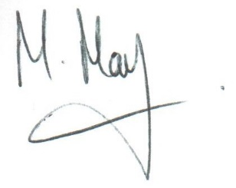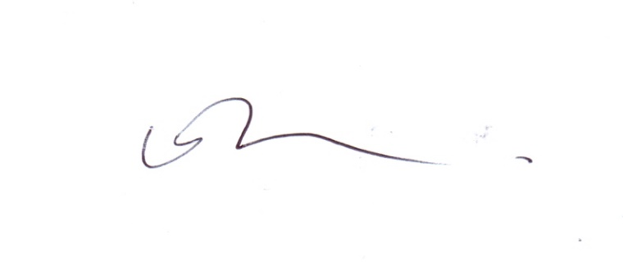
Mr M May Dr N Rice
Deputy Headteacher Director of Learning

