**Porth Community School**



**Behaviour for Learning Policy**

**Version control:**

|  |  |
| --- | --- |
| **Document Name** | **Behaviour for Learning Policy** |
| **Document Owner** | **Porth Community School** |
| **Authors** | **AHT** |
| **COG David Brooks** |  |
| **Headteacher Yvonne Jones** |  |
| **Approval Date** | **05.05.2022** |
| **Previous Document** | **22.01.2019** |

**Contents**

|  |  |
| --- | --- |
| **Content** | **Page No.** |
| Introduction | 3 |
| 1.Policy Aims | 3 |
| 2.Policy Principles | 3 |
| 3.Staff Responsibilities | 3 |
| 4.Praise and Rewards | 4 |
| 5.Managing behaviour inside and outside the classroom – The School Rules | 4 |
| 5.1.School Rules and Classroom Rules | 5 |
| 5.2.The Re-engagement Ladder | 5 |
| 5.3 Lower School Re-engagement Ladder | 6 |
| 5.4 Middle and Upper School Re-engagement Ladder | 7 |
| 5.5 Fixed Term Exclusion | 9 |
| 5.6 Reports and Pastoral Support Plan (PSP’s) | 10 |
| 6.0 Beyond the school gates | 10 |
| 7.0 School Privileges | 11 |
| 8.0 Mobile Phone Policy | 11 |
| 9.0 Dress Code | 11 |

**Behaviour For Learning Policy**

“If we are not modelling what we are teaching, then we are teaching something else” - Helen Flanagan

## Introduction

At Porth Community School, we strive to provide an environment where each and every pupil has the opportunity to learn and develop as an individual. The key to good learning is good behaviour that is managed pro-actively. Our behaviour for learning policy is based upon developing respect within our pupils which will prepare them for life within their community and the world of work. When enforced it enables teachers to teach in a collegiate and respectful learning environment whilst also ensuring that pupils can learn without distraction in a nurturing atmosphere. Positive relationships between pupils and all staff are the key to ensuring that everyone in the community is able to work to their full potential and enjoy being here.

The key to this policy lies in the hands of the staff that will use it on a daily basis. All staff **must** use this policy in a consistent fashion in order to ensure that our pupils are receiving the same messages, experiences and treatment from every classroom in the school, as well as every member of staff around the school site. All staff **must** praise, reward, discipline, control and order pupils in and around the school. The moment pupils see this is not the case will be the point at which this policy breaks down.

## Policy Aims

* All pupils are happy, feel valued in the community and achieve their best
* All pupils demonstrate respect for others
* All pupils are included within the learning experience, whatever their needs, differences or problems
* No one is excluded from our learning community

## Policy Principles

* **All** individuals take **personal responsibility** for their actions and the effect that these have on the people around them
* Staff clearly demonstrate that they know their pupils and their needs. Differences should be recognised and needs met effectively.
* High expectations from all – for all
* Effective communication across the school and with parents/carers

## Staff Responsibilities

There are a number of expectations pupils should expect from staff. All staff should:-

* Arrive at lessons on time to meet and greet pupils and supervise a calm exit from the classroom.
* Ensure that learning intentions are clear, lessons well organised, interesting, appropriate and work is sensitively differentiated.
* Take the register within the first 15 minutes of the lesson and late arrivals recorded and dealt with swiftly.
* Set clear expectations, be fair and engage pupils while applying a positive approach towards discipline.
* Use a consistent approach in dealing with behaviour and recognising achievement and effort.
* Demonstrate to pupils courteous, considerate, polite and pleasant behaviour at all times and should never use any form of abusive or humiliating remarks.
* Manage pupils behaviour in a calm and controlled manner and allow pupils to make a positive fresh start.
* Ensure that they update their understanding and skills in managing behaviour effectively by taking advantage of Professional Development opportunities.

## Praise and Rewards

At Porth Community School, we strive to provide an environment where each and every learner has the opportunity to learn and develop as an individual. The key to good learning is good behaviour that is managed pro-actively. Supporting this is the pro-active use of praise in order to develop the emotional resilience that learners need to take on the challenge of learning.

When used in its entirety it enables teachers to recognise success and celebrate this with the learner, not to the learner. It is important that we recognise, acknowledge and reward individual achievements by pupils. Praise points should be applied consistently and in the majority of cases should outweigh sanctions. Positive behaviours should be rewarded using class charts.

**Class Charts is used on a daily basis to allocate Praise Points**

1. **Rewards/Behaviour Points**

* At class room level praise points will be allocated daily for:-

Consistent good behaviour -

* An exceptional piece of work
* For having 100% weekly attendance & punctuality.
* For attendance at revision clubs
* For being helpful
* For being a Form Rep/Deputy Form Rep
* For being an Assembly Assistant
* For taking part in school events
* For charity work
* For debating
* For Leadership Skills
* For being Independent Learners
* For Mentoring
* For Motivation
* For Organisation
* For Participation
* For Perseverance
* For Progress
* For Public Speaking
* For Singing
* For being a Team player
* Improvement in work/behaviour

Post cards/ Text messages are to be sent home when 30 Praise points have been reached within an area of Learning. - **This should be carried out by the Director of Learning in each area at the request of the member of teaching staff.**

**Postcards/Texts should also be used for one off excellent achievements.**

**Fortnightly**

Each **Director of Subject** will identify a pupil of the Fortnight to be praised in The Head of School assembly.

**This information must be forwarded to the member of staff taking the assembly every other Friday.**

**Termly**

Pupils accumulate points over the course of each academic year. At the end of **each term**, certificates will be awarded to pupils based on the number of positive points they have accumulated in each school of Learning – Communication, Life Skills and STEM.

Certificates will be awarded during Year assemblies in the following way:

* When a pupil has 30 positive points they will be awarded a Bronze Certificate.
* When a pupil has 50 positive points they will be awarded a Silver Certificate.
* When a pupil has 70 positive points they will be awarded a Gold Certificate.
* When a pupil has 80+ positive points they will then receive a Platinum Certificate.

The 5 pupil(s) who have achieved the highest number of positive points and the fewest detentions within each Year group will also be acknowledged in the following way Every Term:

* Autumn term – £5 voucher
* Spring term - £5 voucher
* Summer term - £10 voucher

These pupils names will be displayed on an Achievement Board and School App.

**Heads of School will oversee this and presentations will take place in an end of term assembly.**

|  |
| --- |
| **Teachers are entitled to teach**  **Learners are entitled to learn**  **Everyone is entitled to respect, support and acceptance** |

## Managing behaviour inside and outside of the classroom – The School Rules

The school endeavours to provide a safe learning environment where all pupils can feel and be safe, enjoy and achieve. The school has developed a set of rules which will equip our pupils for good learning and set them up for the world of work. These school rules and classroom rules are all based on;

**Respect, Responsibility and being Ready to Learn.**

## School Rules and Classroom Rules

**Respect**

Respect your teacher, classmates, all visitors and school property.

Follow the instructions of all members of staff, immediately.

Foul or offensive language is not to be used in or around the school.

**Responsible**

Arrive on time to school and to all lessons ready to learn.

Abide by the school internet and Computer access policy, including the use of social media outside of school hours.

Take responsibility for your own behaviour and how it impacts on the learning of fellow class mates - do not disrupt the learning of others.

**Ready to Learn**

Come equipped to school – pen, pencil, calculator, books and correct uniform.

Complete all work and homework to the best of your ability and hand it in on time.

Engage fully in all classroom activities including group and oracy activities.

Classroom Teachers within the Primary Phase will refer to the three headings Respect, Responsible and Ready to Learn and make these rules to suit the pupils level of understanding.

|  |
| --- |
| The Re-engagement Ladder |

We want all learners to enjoy school and flourish in a learning environment that is stimulating and challenging. However, we acknowledge that there will be times when misbehaviour will exist. The school then implements a **re-engagement** system that demonstrates to all learners that actions need to be corrected and relationships repaired. This is known as the school Re-engagement Ladder/The R Ladder.

**5.3 Lower School Re-engagement Ladder**

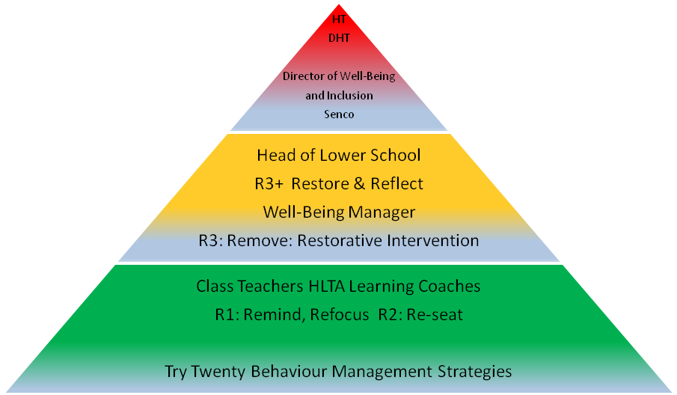

Lower School Positive Behaviour for Learning.

The Golden Rules in the Primary Phase will underpin the values for positive behaviour for learning.

Respect: We are gentle, we don’t hurt anyone

We are honest

We are thoughtful and kind

Responsible: We keep safe

We look after belongings

We play well together

Ready to Learn: We listen

We work hard

We use time well

In addition, children will help their teachers produce a set of Class Rules which are specific to their class and learning areas.

* 1. **Middle and Upper School Re-engagement Ladder**

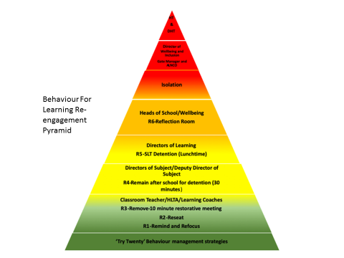

**Try 20 strategies**

**Staff should ensure that they use a number of the ‘Try Twenty Strategies’ prior to using the formal Re-engagement ladder.**

Redirect Behaviour Change of Task Positive Adult Talk – Always find a Positive Comment Change of face Caring Presence Provide Responsibility Distraction Partial Agreement Pupil given clear choices Reminder of Past success Use of Knowledge of pupil to avoid conflict Use of Humour Stay Calm Allow Time Consistent Approach Ensuring Clear Routines Teacher Movement Around the Classroom Visual Smiley Face on Board Use of Non Verbal Cues Show you are Human

**R1 = Remind, Refocus.**

Teachers use a wide range of strategies to support positive behaviour. This should include **reminding** the learner of the class expectations and **refocusing** the pupil. If a learner does not respond then the teacher issues a R1. This is a formal warning to the learner that their behaviour needs improvement.

Minor disruption of the learning of others.

Minor inappropriate / silly comments.

Not doing what is asked when asked

**R2 = Reseat within the classroom.**

**I**f the learner does not respond to the teacher issuing an R1 the learner should be reseated within the classroom. An R2 should be issued.

Repeat of any offense of R1.

Repeated disruption of the learning of others and poor behaviour.

Repeated inappropriate behaviour or challenge of the classroom teacher.

**R3 = Remove – Faculty Parking.**

Staff make use of the Faculty Parking Rota.

Break time / 10 minutes after school detentions overseen by the **classroom teacher** to discuss with the pupil the reason as to why they were placed in Faculty Parking. (When an **R3** has been issued). A Restorative conversation should be held between the classroom teacher and pupil.

Repeated R1 and R2 behaviour.

Offensive language not directed at the member of staff.

Repeated disruption or refusal to follow instructions.

**R4 = Remain**

30 minute afterschool detention held by the Head of Department. Text or E mail must be sent 24 hrs prior to the detention by the subject area Director/Deputy Directors. If the pupil is in detention for failure to attend a restorative meeting with a member of staff, part of this detention should be used for the member of staff to have this restorative conversation with the pupil with the support of the subject area Directors/Deputy Directors.

Refusal to follow instructions of Parked member of staff.

Disruption during cool down (When Parked in Faculty).

Refusal to go to Parked Room.

**R5 = Remain SLT**

Senior detentions are overseen by SLT and run every day for half an hour during the lunch time period. They take place when an **R5** has been issued. Directors of Learning should over see their own departments in the first instance. Text or E mail to be sent 24 hrs prior to the detention. If the pupil is in detention for originally failing to attend a restorative meeting with a member of staff, part of this detention should be used for the member of staff to have this restorative conversation with the pupil with the support of SLT.

**R6 = Reflection Room**

Covered by TLR holders and SLT only. Reflection room runs every afternoon and for half an hour after school. Parents must have 24 hours prior notice to their child being placed in the Reflection Room via Text, E mail or phone call. This is overseen by the Heads of School and Wellbeing Co–ordinators. **Parents must be informed if their child has been placed in the Reflection Room.**

Learners who have been involved in a serious incident for which there is an on-going investigation or learners who have not responded to other strategies and whose actions necessitate isolation from the rest of the community. This is immediate and should be overseen by the Wellbeing team or SLT.

Physical Assault on a pupil.

Intimidating / aggressive behaviour towards peers / staff.

Verbal abuse.

Refusal to Parking.

**\*Only the Wellbeing Team and SLT can place a pupil in Senior Detention and Reflection Room.\***

**ISOLATION –** Isolation is used for continued defiance or a serious breach of the school rules. Pupils are placed in isolation for a full day. Meaningful work is provided and a restorative conversation takes place prior to the pupil being placed into Isolation. Parents are informed at least 24 hours in advance.

\***Only C Grech and Y Jones can place pupils into Isolation.**

**The Gate** – Pupils who are regularly placed in The Reflection and Refocus Room will be monitored closely. Behaviours will be tracked and they may be placed within the GATE provision. Pupils will work closely with the Gate Manager to look at strategies and targets to support behaviour. Pupils may have particular lessons targeted or be placed in the Gate provision for whole sessions.

**5.5 Fixed Term Exclusion**

TheHeadteacher makes all decisions regarding exclusions. Learners that are excluded from school are only done so where a learner’s continued presence on site would be harmful to an individual or the learning community or in response to a serious breach of the school behaviour policy. A letter is sent home and a member of SLT will contact the parents via telephone. After any exclusion a meeting will be carried out by the Wellbeing Team/Assistant Head/ Deputy Head/ Head Teacher and the parent to discuss the pupil’s behaviour. **Only the HEADTEACHER can exclude.** The school follows all guidance as set out in the Welsh Government document ‘Exclusion from schools and pupil referral units’ 171/2015

## Fixed Term Exclusion Protocol

The school does not believe that exclusion supports improved behaviour and therefore a key priority is for zero exclusion. However fixed term exclusion can be used as an important part in ensuring and maintaining a safe environment for our pupils and staff. Fixed term exclusions may be used when it is felt that:

* The pupils continued attendance at the time would put others at risk
* The pupil has repeatedly not responded to other approaches

## Exceptions to zero permanent exclusion

There may be exceptional circumstances where in the Headteachers’ judgement it is appropriate to permanently exclude a pupil in order to ensure the safety of the rest of the community. These can include:

• Physical assault against another pupil or a member of staff

• Sexual abuse or assault

• Supplying drugs

Bringing an offensive weapon into school.

In these circumstances, our duty of care to the rest of the community outweighs the needs of the individual.

**5.6 Reports and Pastoral Support Plan (PSP’s)**

Pupils will be placed on daily reports as follows:

* Stage 1 – Green - Form tutor to monitor.
* Stage 2 – Amber – Head of school to monitor.
* Stage 3 – Red – Gate Manager to monitor.

A PSP will automatically be triggered after an exclusion

## Beyond the school gates

We recognise that often events happening outside school can impact upon the learning capacity of a learner in school. As such the school will take action against learners whose behaviour outside school has a negative or harmful effect on anther learner or who damages the reputation of the school in our community.

## School Privileges

When a pupil’s behaviour falls short of the Porth standard they will not be asked to represent the school at events nor will they be invited on external trips. Heads of school will have the final decision on this.

## Mobile Phone Policy

Mobile phones are not to be used anywhere within the school buildings. If they are seen being used they will be confiscated immediately. They will be returned at the end of the day in the first instance and will have to be picked up by parents if the phone is confiscated again.

## Dress Code

**Our pupils wear school uniform because:**

* We believe that wearing a uniform protects pupils from discrimination in terms of the

pressures of expensive fashion clothing

* We believe that dressing smartly is preparing pupils for a business-like attitude to work
* The uniform allows our pupils to be readily identifiable in public places.

We expect pupils to wear the correct uniform while travelling to and from school.

The school uniform is simple and practical and we rely on parent/carers support to

ensure their children wear it correctly and to be neat and tidy at all times.

**Coats**

We would strongly advise pupils to wear coats that are clearly visible to traffic to protect

them on their journey to and from school. Many coats now have reflective strips sewn

into them. The following coats are NOT allowed: coats/jackets with lettering, logos or

motifs; coats/jackets containing unacceptable material e.g. leather (real or lookalike),

denim, corduroy, fur (real or artificial) etc. Baggy jumpers, cardigans, hooded tops,

tracksuit tops etc. cannot be worn as a top coat.

**Scarves, Hats and Gloves**

They must be plain black, grey or navy with no motifs.

**Shoes**

(Classic/Traditional/Formal) Black, low heeled/flat school shoes. (NO boots, high heels, trainers, sporting or casual styles, platform soles or canvas shoes, of any kind).

Black leather, plain converse shoes may be worn on the condition that there is no white, other colours or markings on them.

**Hair**

No unacceptable hair styles e.g. unusual dyes, braids, excessively long, short or shaved,

etc. No shaved heads, beards or facial hair. Hair accessories for girls only should be simple and in burgundy, grey, black, or gold

**Jewellery**

The only jewellery allowed is a watch and a single pair of small plain stud earrings in the

lower lobe of the ear. All other nose, face, body or multiple ear piercings must be removed for Health and Safety reasons.

**Make up**

Make up and long/false or varnished nails are not acceptable

**Badges**

No badges or motifs are permitted on any item of clothing except the school badge

and those connected with school activities and County or National sports colours.

**Boys Uniform (Lower School)**

Grey tailored school trousers

*Burgundy or white polo shirt with school badge

*Burgundy cardigan or jumper with school badge

*Please note only school badged cardigans and jumpers may be worn in school*

*Grey socks

Footwear to be confirmed

**Optional for Summer Term**

Grey tailored school shorts

**Girls Uniform (Lower School)**

Grey tailored school trousers and/or grey tunic and/or grey pleated skirt

*Burgundy or white polo shirt with school badge

*Burgundy cardigan and/or jumper with school badge

*Please note only school badged cardigans and jumpers may be worn in school*

*Grey socks

**Optional for Summer Term**

Gingham school dress with white socks (Yellow)

Grey tailored school shorts

**Boys Uniform (Middle and Upper School)**

*Grey Blazer with school badge

*Middle/Upper School Tie

Plain white traditional school shirt

Grey tailored school trousers (NO cords, jeans, chinos or other casual trousers).

Grey socks

**Optional**

*Burgundy cardigan with school badge

*Burgundy jumper with school badge

*Burgundy fleece with school badge

*Please note only school badged cardigans and jumpers may be worn in school*

**Girls Uniform (Middle and Upper School)**

*Grey Blazer with school badge

*Middle/Upper School Tie

Plain white traditional school shirt

Grey tailored school trousers (NO cords, jeans, chinos or other casual trousers) and/or grey pleated school skirt knee length skirt with a maximum **of 6 cm** above the knee being accepted.

Grey socks or opaque black tights

**Optional**

*Burgundy cardigan with school badge

*Burgundy jumper with school badge

*Burgundy fleece with school badge

*Please note only school badged cardigans and jumpers may be worn in school*

**ALL STAFF ARE EXPECTED TO ADHERE TO THIS POLICY.**